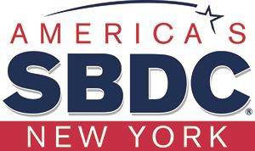

GOING GLOBAL
Business Opportunities in China

Jinshui Zhang
International Business Development
New York State Small Business Development Center

Opportunities in China
- The Chinese market continues to offer tremendous opportunities for U.S. businesses.
- The number of U.S. firms doing business with China has been growing in these years
- Attractive new market with large number of consumers and rapid growth of middle class and income
- Fastest growing foreign market for U.S. products

- High demand for brand name products or services from the U.S.
- Low cost labor force
- A massive pool of well-educated surplus laborers
- Growing labor productivity and income growth
- Low cost raw material / manufactring
- A boom in infrastructure investment
- Globalization and market reforms

  - In addition, increasing interest in investment in the U.S. is growing rapidly in recent years through different channels and in various manners.
  - This is an opportunity for those NY businesses looking for investment in business expansion, market development, research and development, etc.

Opportunities for Industries
- New/renewable energy /Energy saving /eco-friendly materials
- Environmental protection technology / equipment
- Information & communication technologies / service
- Artificial intelligence /intelligent manufacturing
- New medical device / equipment
- Biomedicine/pharmaceutical
- Health care products & service
- New / advanced materials
- New energy vehicles
- Hi-end equipment design & manufacturing

These opportunities are in the heart of China’s most economically advanced and industrial regions:

- Provinces: Shandong, Jiangsu, Zhejiang, Anhui, Guangdong, Sichuan, Hubei etc.

- Metro Cities: Beijing, Tianjin, Shanghai, Chongqing, Shenzhen, Guangzhou, etc.

Map of China
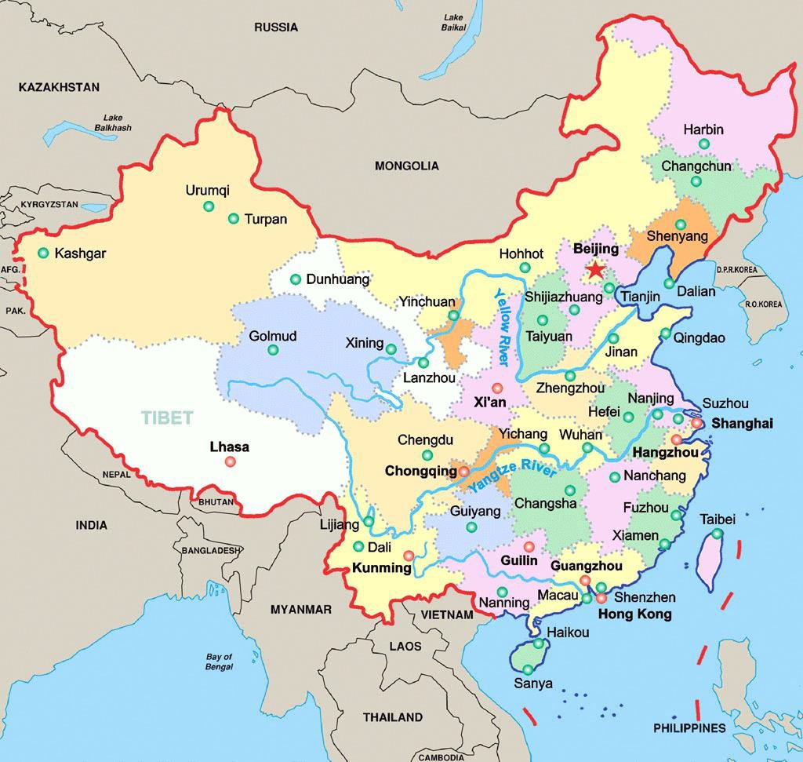

Interested in Working with NY Businesses
  - New York itself is a brand name for their technology, industries and products. The Chinese like to work with NY businesses and service providers.
  - Preferential policies for these industries to both domestic and foreign businesses at different levels (financial support, land supply, tax incentives, case-based special treatment, etc.)
  - Flexible forms of doing business: wholly-owned, joint venture, partnership, co-production, incubation in industrial or tech parks, etc.

The NY SBDC is a Partnership: the U.S. Small Business Administration, SUNY, New York State, higher education institutions and the private sector.
Providing one-to- one business advisement, training and research in support of entrepreneurship and economic development for New York State.

Entrepreneurship • Education • Economic Development

NY SBDC Network
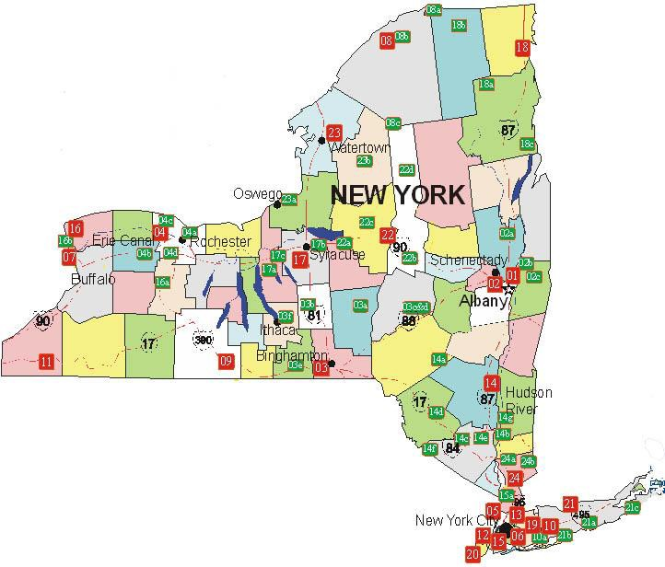
22 Regional Centers, 28 Outreach Offices plus part-time satellites, 98% of
NYS’ population is within 30 minutes of an SBDC service location.

Services of NY SBDC International
Business Development
- International trade, business development and cooperation
- Export information, opportunities, and evaluation of market potentials
- Matchmaking of distributors, suppliers, manufacturers, partners, agents, etc.
- Identification of export processing, investment, sourcing, WFOE, joint venture opportunities.

- Updates and advice on relevant policies, government regulations, taxes, etc.
- Training sessions, seminars, conferences on international trade & business
- Organize trade & business missions to foreign countries coordinating business activities
- Host foreign business and government delegations and coordinate business activities & events

NY SBDC Business Missions to China
- Are designed for NY businesses to enter or expand business/trade development
- Introduce and promote NY business/services
- Organize matchmaking events with selected local companies, manufacturers, suppliers, industrial parks and technology development zones
- Help NY businesses explore opportunities for business and market development
- Have on-site visits to local companies in relevant fields
- Expert translator and coordinator available throughout the mission
- Coordinate visa application and flight reservation

Participation Package
- Participation cost package ($3,900 + international air travel) that covers (for a 10 – 12 days mission):
- All 4 or 5 star hotel accommodations
- All meals and official banquets
- All in-China ground transportation
- Translation service for all mission events and activities
- Business networking receptions
- Mission organized tourist site visits / activities

Be Ready for the Opportunities
  - To maximize these opportunities, you need to plan well before jumping in to a new market
  - Cultural issues, business practice, intellectual property protection, different regulations and compliance, etc.
  - Do your homework, develop a well-planned strategy, and be well prepared
  - Do the RIGHT thing, with the RIGHT people, at the RIGHT time, in the RIGHT place, in the RIGHT manner.

The current U.S. – China Economic
Relationship and Trade Dispute
- The U.S. and Chinese President (Trump and Xi) agreed to restart trade talks at G20 Summit in late June with optimism that the trade dispute could be defused. Another round of negotiation between top negotiators will be held in Shanghai this week.
- Resolving the differences between the two sides is clearly not a simple matter. It is, however, in their best interests for U.S. and China to reach an agreement that addresses key issues such as market access, intellectual property rights, and joint-venture technology transfer.

  - There is no telling whether we’ve already witnessed the highest points of tension between
U.S. and Chinese officials in the battle over international trade. If so, the auto, tech, and agriculture industries may have a smoother road ahead.
  - On the other hand, if precedent has taught us anything, it’s that nothing is certain when it comes to trade wars.

CONTACT INFORMATION
Jinshui Zhang, Director
International Business Development
New York State SBDC Central Administration
Phone: 518-944-2857
Fax: 518-320-1593
Email: jinshui.zhang@nysbdc.org Website: www.nysbdc.org
Address: New York State SBDC Central 10 North Pearl Street Albany, NY 12207

Questions & Answers

THANK YOU !

