SPRING
WEDNESDAYS
Melville N3045 1-2:20PM

2023

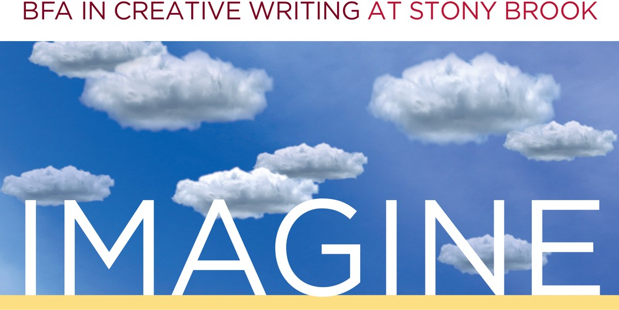
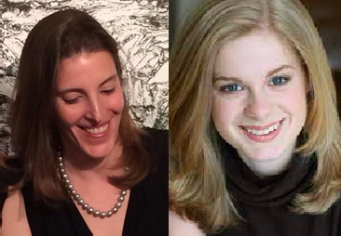
FEB. 8 ~ Writers LB Thompson & Marissa Levien
Join poet and nonfiction writer LB Thompson and novelist Marissa Levien as they showcase their award-winning work. Q&A to follow.

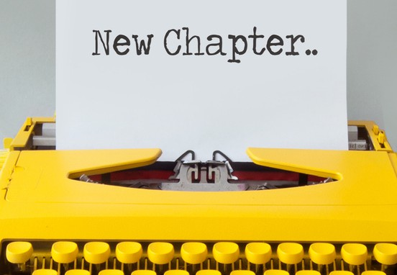
FEB. 22 ~ Graduate Instructor Reading
Find out what your CWL 202 and 300-level instructors are working on in this multi-genre reading. Q&A to follow.

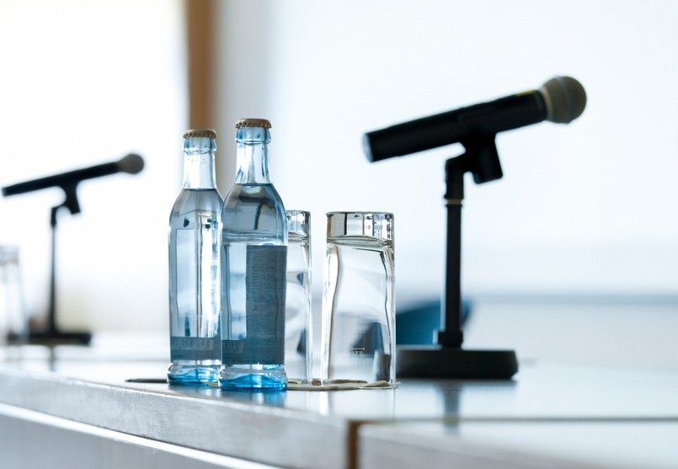
MAR. 22 ~ Life After the Creative Writing Major/Minor
Join us for a lively panel of graduates from the Stony Brook BFA program who went on to pursue graduate MFA or MA degrees, a career in publishing, or something out-of-the-box.


APR. 26 ~ Student Showcase
Undergraduate writers, it's your turn to shine! Faculty-nominated writers will share their work with their peers in a public reading.

To request accommodations or for more information, contact cwlundergrad@stonybrook.edu

