SPRING
WEDNESDAYS
Melville N3045 1-2:20PM

2022

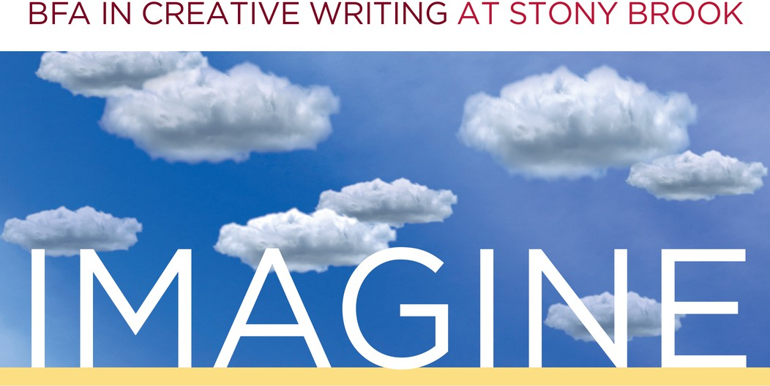



FEB. 2 ~ Welcome Back-Get Together!

Welcome Back!
Welcome back to a new semester, Creative Writers! Please join us for snacks, drinks, and some casual socializing with creative writing students and faculty! Hosted by Genevieve Sly Crane.

MAR. 9 ~ TA Reading
Find out what your CWL 202 and 300-level instructors are writing! Hosted by Sean Cassidy.

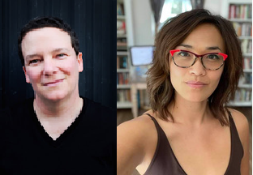
APR. 6 ~ Featured Writers E. Briskin & Molly Gaudry
Fragments and flashes across the genres, featuring experimental forms writers E. Briskin and Molly Gaudry! Hosted by Bobby Crace and Sponsored in part by the Lichtenstein Fund.

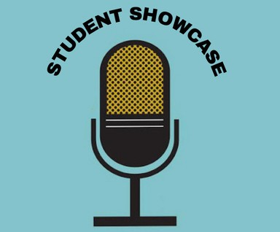
MAY 4 ~ Student Showcase
Undergraduate writers, it's your turn to shine! Hosted by Felix Grygorcewicz.

To request accommodations or for more information, contact cwlundergrad@stonybrook.edu

